**CHE517 ADVANCED PROCESS CONTROL**

**FINAL EXAM**

Professor Shi-Shang Jang Jan. 13, 2016

**Problem #1 Interpretation: (20%)**

(1) Sampling time

1. Dead beat Control
2. Feedforward Control
3. Cascade Control
4. First-Order Hold

**Problem #2 (20%)**

Consider the control scheme for the solid drying system shown in the following Figure:

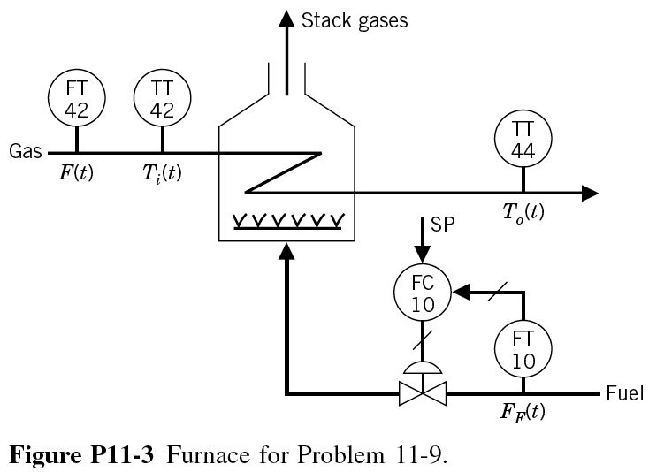

The major disturbance to this process is the moisture content of the incoming solids. For this disturbance, the control system responds quite slowly. It is desired to implement a feedforward system to improve this control. After some initial work, the following data have been obtained:

Step Change in inlet moisture=+2%

|  |  |  |  |
| --- | --- | --- | --- |
| Time (min) | Exit  Moisture, % | Time (min) | Exit  Moisture, % |
| 0 | 5 |  |  |
| 0.5 | 5 | 5 | 6.6 |
| 1 | 5.1 | 5.5 | 6.7 |
| 1.5 | 5.2 | 6 | 6.8 |
| 2 | 5.4 | 6.5 | 6.9 |
| 2.5 | 5.7 | 7 | 7 |
| 3 | 5.9 | 7.5 | 7 |
| 3.5 | 6.1 | 8 | 6.9 |
| 4 | 6.3 | 8.5 | 8 |

Step change in output signal from moisture controller, MC-10=+25%CO

|  |  |  |  |
| --- | --- | --- | --- |
| Time (min) | Exit  Moisture, % | Time (min) | Exit  Moisture, % |
| 0 | 5 | 5 | 3.81 |
| 0.5 | 5 | 5.5 | 3.7 |
| 1 | 4.95 | 6 | 3.55 |
| 1.5 | 4.93 | 6.5 | 3.45 |
| 2 | 4.85 | 7 | 3.35 |
| 2.5 | 4.7 | 7.5 | 3.25 |
| 3 | 4.6 | 8.5 | 3.1 |
| 3.5 | 4.4 | 9.5 | 3.03 |
| 4 | 4.2 | 11.5 | 3 |

Identify the control objective, the disturbance, and the manipulated variable.

(a) Draw a complete block diagram for this process that shows the effect of the inlet moisture on the controlled variable. Include all known transfer function.

(b) Develop a feedforward control scheme using the above data. (Hint: draw a step response plot, and find gain K, time constant τ and dead time D).

**Problem #3 (20%)**

Derive a pulse transfer function (z-domain) for the following plants with a zero order hold and a sampling time of 1:

1.  (6 points)
2.  (6 points)
3.  (7 points)

**Problem #4 (20%)**

Consider the following Internal Model Control Structure (or Model Predictive Control Structure:

GI

Gm

GP

ys

e

d

y

ym

u

+

+

+

-

-

+

Show that:



**Problem #5 (20%) Take home**

Consider a high order process

$$G_{p}\left(s\right)=\frac{1}{{\left(s+1\right)}^{4}}$$

with a load process

$$G_{L}\left(s\right)=\frac{5}{\left(2s+1\right)}$$

1. Obtain an approximate first order plus dead time model using a reaction curve approach.
2. Tune an optimum PID controller based on this approximate model. What is the PID setting?
3. How does this PID controller perform in case a set point change from 0 to 1?
4. How does this PID controller perform in case the following pulse function is implemented to the load?

$$L\left(t\right)=\left\{\begin{matrix}1 0≤t≤0.5 \\ 0 0.5≤t≤1\end{matrix}\right.$$

repeated in every time interval of 1.

1. Design a feedforward controller based on the approximate plant model and assume that the load model *GL(s)* is completely known.
2. Compare the feedforward controller to the PID controller in case of pulse load function.

M(s)

GP(s)

+

+

L(s)

GL(s)